1820’s 1830’s 1840’s 1850’s 1860’s 1870 – 1899 1900 – 1929 1930 19 year span 19 year span

Dates related to narrators GREEN TEXT
Compiled by Teaching with Primary Sources Program at Southern Illinois University Edwardsville, Last update January, 2013
Disclaimer: Content created in partnership with the TPS Program does not indicate an endorsement by the Library of Congress or Southern Illinois University Edwardsville.

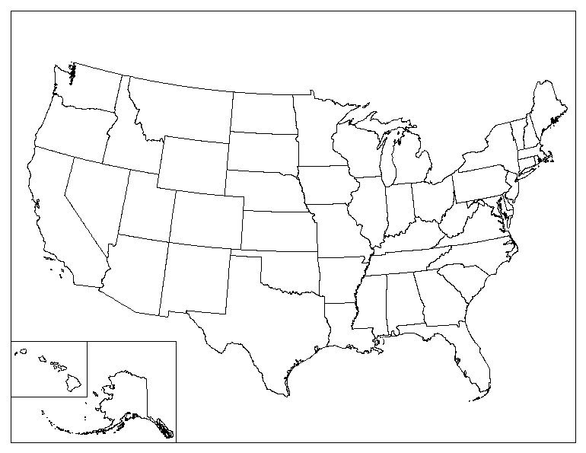

Compiled by Teaching with Primary Sources Program at Southern Illinois University Edwardsville, Last update January, 2013
Disclaimer: Content created in partnership with the TPS Program does not indicate an endorsement by the Library of Congress or Southern Illinois University Edwardsville.

Septima M. Collins
Baltimore, Maryland

Thomas F. Pendel
Washington, DC

Emma F. LeConte
Columbia, South Carolina

Franklin A. Buck
Weaverville, California

