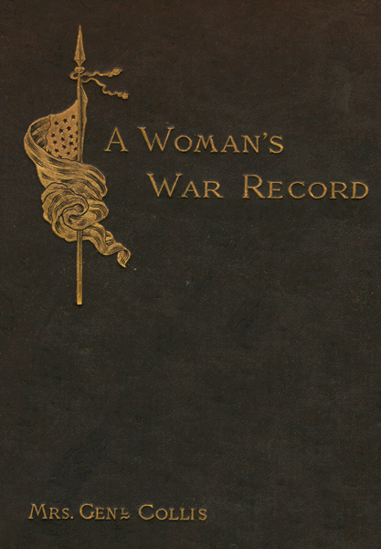
Title
A Woman's War Record, 1861-1865
Creator
Collis, Septima Maria Levy, 1842-1917.
Notes
- Mrs. Collis was the companion of her husband at the front. He raised a company of zouaves at the outbreak of the war, which was later augmented to a regiment, the 114th Pennsylvania.
- Transcribed from: A woman's war record, 1861-1865 / by Septima M. Collis (Mrs. Genl. Charles H.T. Collis) New York ; London : G.P. Putnam's Sons ; Knickerbocker Press, 1889.

Portions of page 1 & 2

A WOMAN'S WAR RECORD.
BY MRS. GENERAL CHARLES H. T. COLLIS.

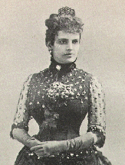
Born in Charleston, S. C., my sympathies were naturally with the South, but on December 9, 1861, I became a Union woman by marrying a Northern soldier in Philadelphia.

Page 74 - 76
It was not until April 14th that I considered my daughter well enough to travel, and then, without waiting for my husband's return from Appomattox,
I started for Philadelphia, taking a steamboat as far as Baltimore. The war was over; my husband was alive and well; my child was recovering; my life was brimful of gladness. With such happy thoughts and in such a mood I reached Baltimore, when I gradually became sensible of an abnormal condition of things, which indicated some fresh outbreak, and I became alarmed. People were hurrying through the streets, groups of men and women were engaged in eager discussion; something had happened. There were no cheers, no music; it was gloom! There had been a calamity. What was it? "The President has been murdered," whispered my orderly, who had gone for information, "and nobody can go North today." Oh, horror! I had learned to love Mr. Lincoln then, as younger people today love to read about him. I had seen him weep, had heard him laugh, had been gladdened by his wit and saddened by his pathos. I had looked up to him as one inspired. How glad I was afterwards to know that his untimely death was the act of a mad fanatic, and that my people who had fought a desperate but unreasonable war had no hand in it.
When I could collect my thoughts I gathered up my sick child and the little comforts I had brought with me to nourish and sustain her on the journey, and took myself to the nearest hotel, where I remained until the authorities permitted me to continue on my way the next morning. Later I was among the sad and silent multitude who witnessed the passing of the funeral cortége up Broad Street, in Philadelphia. There were many joys in my life then which made me the happiest of women, but I could willingly have sacrificed some of them to bring that best of the very best back again into life.
sympathies-
brimful-
fresh outbreak-
gloom-
calamity-
wit-
pathos-
mad fanatic-
silent multitude-
cortége-

